Writing a Results Section

Purpose
- Present your data to the readers in a manner that is:
  - Clear - You want the reader to fully understand your data.
  - Concise - You want to communicate your data with as few words as possible.
  - Easy to Follow - You want the reader to be able to understand your results with as little effort on their part as possible.

Writing the Text
- Provide a description of the trends you observed in your data.
  - The description should indicate how your treatment levels compared to each other. You should only have ~one sentence per dependent variable.
  - “On average, yeast utilizing glucose produced more carbon dioxide than yeast using sucrose.”
  - “Yeast given sucrose produced nearly two times the amount of ethanol than yeast given lactose.”
- Talk about your data as a whole, not trial-by-trial or week-by-week.
- Make sure to reference your figures in the text.
  - Referencing figures is similar to how you would include a citation.
  - “As shown in Figure 1,……”
  - “Yeast produced carbon dioxide twice as fast when exposed to heat (Figure 2).”
- Avoid these common mistakes:
  - Reporting raw data - Do not provide the actual values that you are showing in you graphs.
  - Interpreting the data - Do not say that the independent variable caused the difference observed in the dependent variable, and do not reference your hypothesis.
  - Including too much information - Your Results section should be concise; remember, you only want ~one sentence per dependent variable.
  - Including material that belongs in other sections - Don’t include number of trials (Methods), trial lengths (Methods), anything about your hypothesis (Introduction and Discussion).

Creating Graphs
- Make sure to follow these rules when making your graphs:
  - Do not include titles on your graphs - You should use a figure caption to describe the graph instead of a title.
  - Include a descriptive figure caption - The figure caption should describe the independent and dependent variables depicted on the graph, as well as some relevant information that can be quickly summarized, such as sample size.
    - “Figure 1: Average change in carbon dioxide for yeast given glucose and sucrose over the course of five 10 minute trials.”
    - “Figure 2: Average ethanol production for yeast using lactose vs. rice sugar for six 15 minute trials. Bars denote standard error.”
  - Label the axes - Your axis labels should be concise but descriptive, and should include appropriate units.
  - Only include a legend if necessary - This typically occurs when you have more than one independent variable (for example, different concentrations of two or more sugars).
  - Include error bars if possible on bar charts - Error bars should be either standard deviation, standard error, or 95% confidence interval. Do NOT use Excel’s default error bars; you must calculate these yourself and use the custom error bar setting.
  - Ensure the y-axis begins at zero - Starting your y-axis at a point other than zero can give the reader the impression that there is more of a difference between the treatments than there actually was.
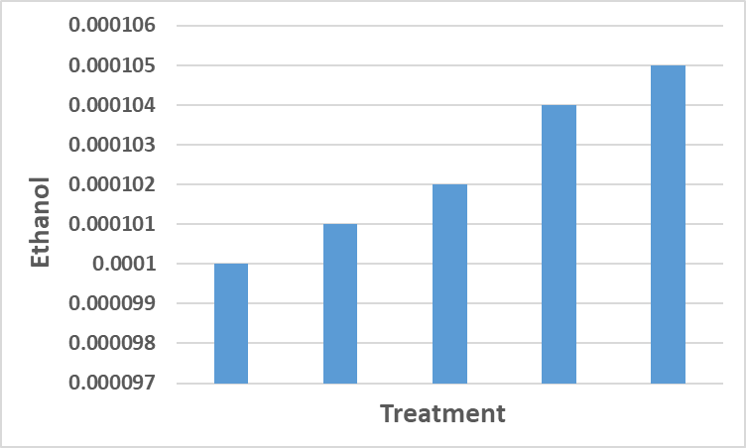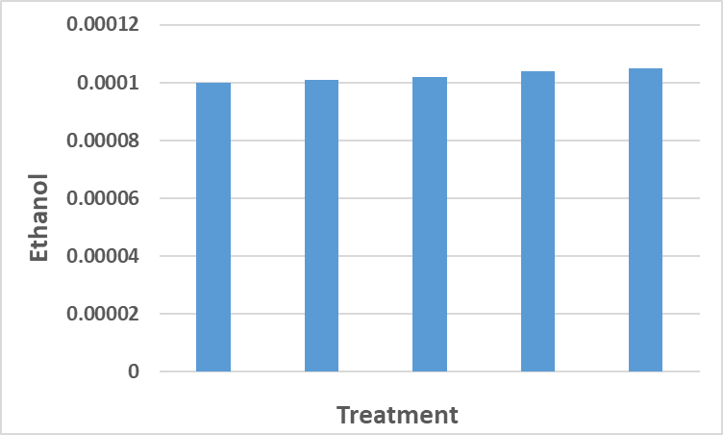
Figure 1. These two graphs depict the same data. Figure 1.a does not start the y-axis at zero, which causes the reader to assume that the difference between treatments is larger than it actually is, whereas Figure 1.b starts the y-axis at zero, which more honestly reflects the data.

- Make sure that you are using an appropriate graph for your data:
  - Categorical Data is when your independent variable can be broken into discrete categories (such as different types of sugar, or when you use only a few different concentrations of one sugar).
    - Categorical data should be depicted using a bar chart.

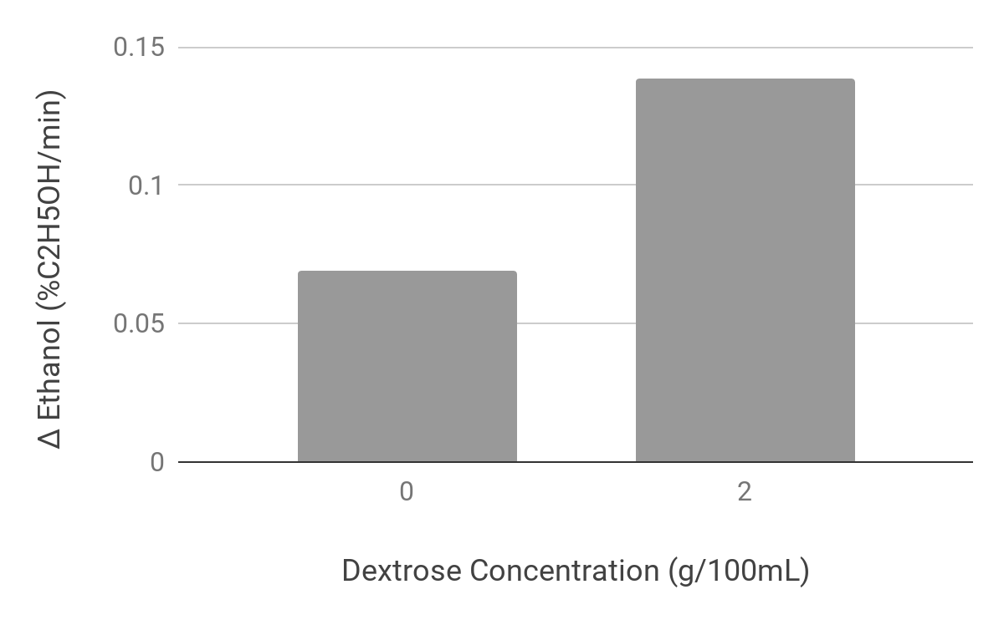
Figure 2. An example of a bar chart.

  - Continuous Data is when your independent variable can be any value within a range (such as many different concentrations of sugar, which can be any value from 0% to 100%).
    - Continuous data should be depicted using an x-y scatter plot.

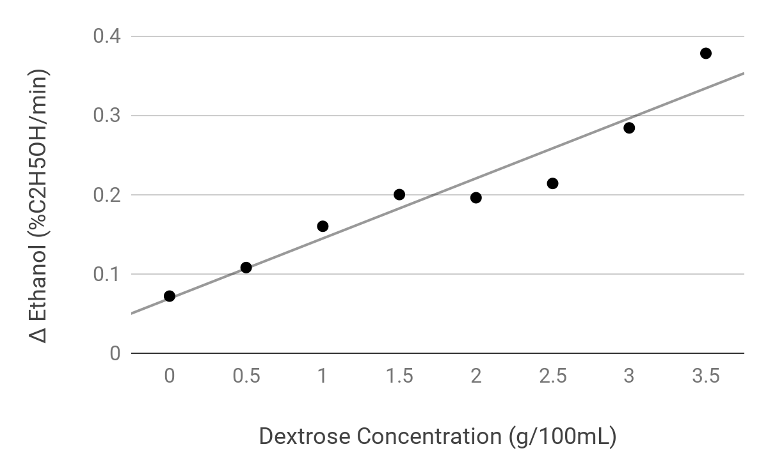
Figure 3. An example of an x-y scatter plot with a trendline.

Statistics
- Statistics are not required, but will make reviewers regard your manuscript more favorably.
- Statistical test provide additional support for your hypothesis by telling you how confident you can be that your independent variable is affecting your dependent variable.
- Depending on the type of data you have, you should use a different type of statistical test.
  - When comparing exactly two different treatment levels, you should use a t-test (R8.3).
    - Example: You are comparing which of two sugars (sucrose and dextrose) causes yeast to produce the most ethanol.
  - When comparing three or more different treatment levels, you should use an ANOVA (R8.6).
    - Example: You are comparing which of 4 different pH buffers (pH 4, 5, 6, and 7) causes the yeast to produce the most ethanol.
  - When determining if there is a relationship between two continuous variables, you should use a correlation analysis (R8.8).
    - Example: You are determining if increasing the concentration of sugar (from 0% to 5%) is related to the amount of ethanol produced by yeast.
- You should calculate the p-value; this value will be between 0 and 1.
  - In biology, a p-value of less than 0.05 indicates significance (that there is a meaningful difference between groups in a t-test or ANOVA, or that there is a meaningful relationship between variables in a correlation).
  - You should only use the words “significant” or “significance” if you’ve done a statistical test and found a p-value less than 0.05.
  - You should indicate that you found significant or insignificant results in the text of the results, and cite the p-value.
    - “As shown in Figure 1, the yeast treated with sucrose produced significantly more ethanol than the yeast treated with lactose (p=0.003).”
    - “There was no significant relationship between pH and ethanol production (Figure 1, p=0.543).”
    - “There was a significant positive correlation between between the concentration of sucrose added to the yeast and the ethanol produced (Figure 2, p=0.038).”
- You should state the statistical test performed in the Methods section.

